**Analysis of rating of Coffee Shops in Riyadh: (MVP)**

The goal of the project is to analyze Riyadh cafes based on people’s ratings of most cafes in Riyadh and based on these ratings we will establish a Lava coffee shop.

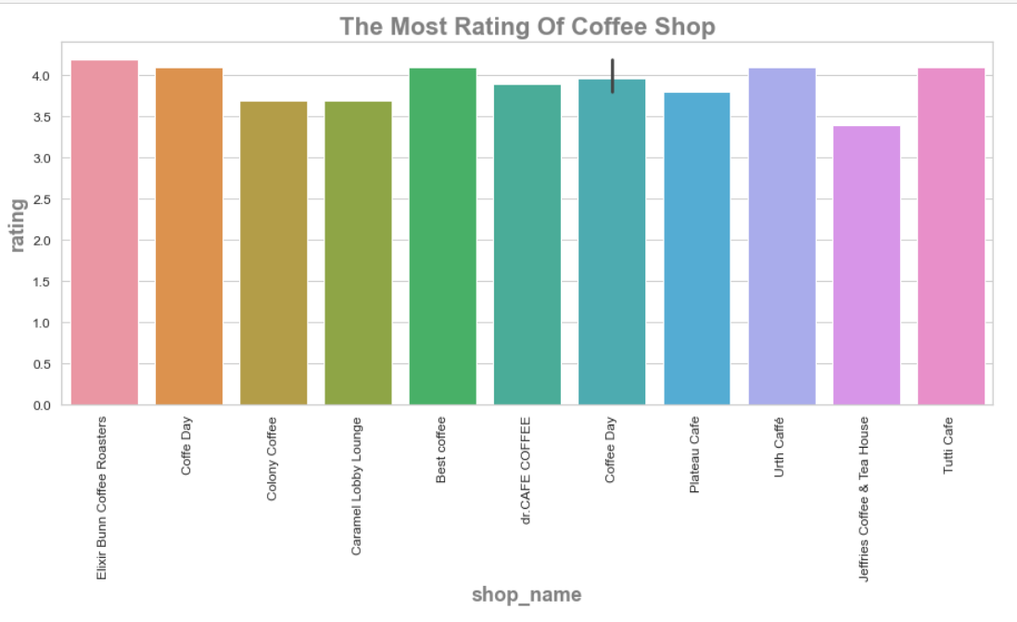

From my first impression we get an answer for:

what's the most coffee shop has highest rating based on quality of coffee and the price?

and after analysis we noticed the “Elixir Bunn coffee Roasters” has the highest rating.